#importing libraries:
library(psych)
library(effsize)
library(apaTables)
library(moments)

#The three variables to be studied are : coffee consumption, whether or not psychology was first major and consistency
#consistency is the average of 10, so we will add another column con_avg
con_data <- data[,26:35]
data$con_avg <- rowMeans(con_data, na.rm = T)

- #Q1 / What is the level of measurement of each of these three variables?
Level of measurment:
1. Coffee consumption: Ratio
2. whether or not psychology was first major: Ordinal
3. Consistency Average: Interval

#Q2.
  - #a) For the ‘firstmajor’ variable, what proportion of students fall in each category?

table(data$firstmajor)
#71 are no and 101 are yes
noprop = 71/(71+101)
#proportion of no :0.4127907
yesprop= 101/(101+71)
#proportion of yes :0.5872093

- #b) For the full sample, what are the mean, standard deviation, and skewness for coffee consumption and conscientiousness?
#Coffee:
coffeemean = mean(data$coffee, na.rm = T) #5.970588
coffeesd= sd(data$coffee, na.rm = T) #6.926005
coffeskew=skewness(data$coffee, na.rm = T) #1.680131

#Consistency AVerage:
con_mean = mean(data$con_avg, na.rm = T) #3.68469
con_sd=sd(data$con_avg, na.rm = T) #0.6388831
con_skew=skewness(data$con_avg, na.rm = T) #-0.1082667

#Q3.
- #a) Obtain a Q-Q plot for conscientiousness and upload it.

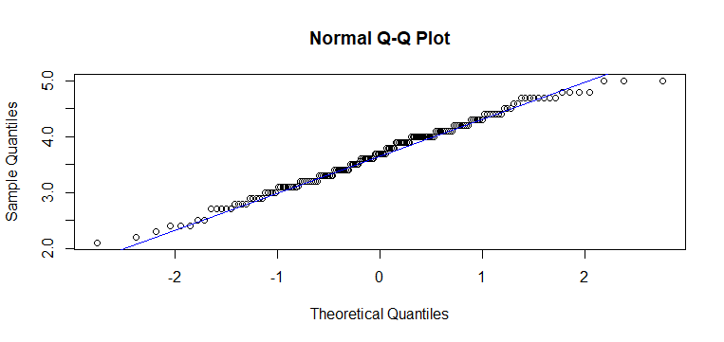
#b) Interpret your Q-Q plot – is conscientiousness normally distributed? How do you know? How does the plot compare with the skewness you reported in 2b above?

As we can see, almost all points line on the line, we can say that the data can be normally distributed.
Also the skewness we calculated is close to 0. Hence we can say data is normally distributed

#Q4. One large national study indicates that on average, Americans drink 11.2 cups of coffee per week. Test the hypothesis that students in our class drink less coffee per week than the average American. Use an alpha level of .05.

a/ Calculate and report Cohen’s d.

-0.182328
#b) Is this a small, medium, or large effect, according to the updated guidelines from Funder and Ozer (2019) that we discussed in class?
#it is a small effect
c) Is it more appropriate here to use a one-tailed or a two-tailed test, given the question?

#AS we only need to test whether students drink less than average or not, one tail test should be used.
d) Report your test statistic, degrees of freedom, and p-value.
#test statistic = -9.8445, df = 169, p-value < 2.2e-16

Q5. Do students who chose psychology as their first major report, on average, higher or lower conscientiousness than students who changed their major to psychology? Test this hypothesis. Use an alpha level of .05.

  - Shape: What are the means of conscientiousness for each group? Who has higher conscientiousness?

no : 3.542254 , yes :3.784818 hence the students who has psychology as first major have more consistency
b) Size: Calculate and report Cohen’s d.

cohen2 = cohen.d(as.numeric(data$con_avg), as.factor(data$firstmajor),alpha=0.05, na.rm = T)
d_con = cohen2$estimate
#-0.3853915
c) Is this a small, medium, or large effect, according to the updated guidelines from Funder and Ozer (2019) that we discussed in class?

#It has a medium effect
d) Significance: Is it more appropriate here to use a one-tailed or a two-tailed test, given the question?

#AS we need to calculate whether mean is higher or lower, two tailed test should be used.
e) Report your test statistic, degrees of freedom, and p-value.

t = 2.4836, df = 149.78, p-value = 0.01
f) Is the difference in conscientiousness between those who chose psychology as their first major and those who did not statistically significant?

Yes there is a statistically significant difference between their means

